**Voice Command Controller for IT Laboratory**

**User Manual Guide**

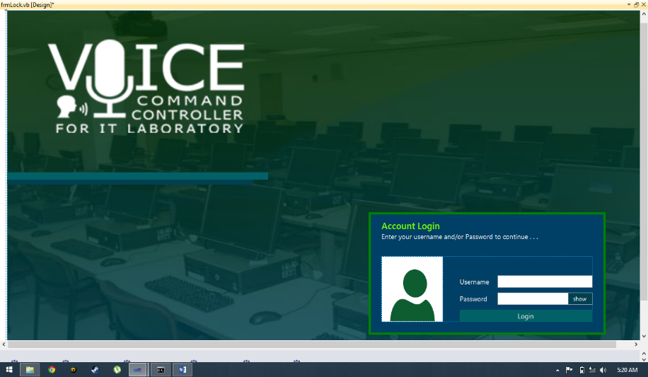

February, 2015 Edition

Quezon City Polytechnic University

Contents

1. Installation Guide
   1. Installing Xampp Server…………………………………………………..
   2. Installing MySql Connector for .NET……………………………………………………
   3. Installing BT Remote PC………………………………………………………
   4. Installing BT Remote PC in Android device…………………………………………………..
   5. Installing USB Bluetooth Transceiver Device……………………………………...................
   6. Installing Wireless Headset (Jabra Stealth)………………………………………………...
   7. Installing Voice Command Controller System…………………………………………………
2. Registering Instructors……………………………………………………
3. Training Speech Recognition Engine………………………………………………………..
4. Network Settings………………………………………………………
5. Application Settings………………………………………………………
6. Word Settings……………………………………………….
7. Keyword Settings……………………………………………
8. Basics of Voice Commands…………………………………………………..
9. Other Voice Commands…………….……………………………………
10. Registering Schedule, Section and Subject………………………………….. …………………
11. Registering Students as Instructor……………………………………………………
12. Registering Students as Client……………………………………………………….
13. Student Monitoring………………………………………
14. Screen Sharing…………………………………………….
    1. Using voice command……………………………..
    2. Using alternative method………………………….
    3. Using graphical user interface……………………
15. Setting the Laboratory Timer………………………………………………………..
16. Viewing and Exporting Attendance…………………………………………………
17. Shared desktop……………………………………………
    1. Using voice command……………………………..
    2. Using alternative method………………………….
    3. Using graphical user interface……………………
18. Sending of files from the server to the clients…………..
    1. Resending of files from the server to the clients…
19. Receiving of files from the clients to the server………..

**Installation Guide**

* 1. **Installing Xampp Server**
     1. Download the latest Xampp Server from the Website [www.apachefriends.com](http://www.apachefriends.com)
     2. After Downloading Xampp Server, double click it and follow the installation instructions.
     3. Run the xampp server and start apache server and MySQL
  2. **Installing MySql Server Connector for .NET**
     1. Download the latest MySql Database from the website [www.oracle.com](http://www.oracle.com)
     2. After Downloading MySql Database, double click it and follow the installation instructions.
  3. **Installing BT Remote PC**
     1. Download and install BT Remote PC from the website [www.androidremotepc.com/downloads/](http://www.androidremotepc.com/downloads/)
     2. After downloading the file follow the installation instruction
  4. **Installing BT Remote PC in Android Device**
     1. Download the App in Google Play Store
     2. After downloading, run and follow the Installation Instruction of the app.
  5. **Installing the USB Bluetooth Transceiver Device**
     1. Plug in the USB Bluetooth device.
     2. The device will automatically install all its resources to the terminal once plugged in.
     3. If it does not automatically install drivers, click the link in the pop-up window of installation status to install drivers from windows update to download and install the appropriate drivers
  6. **Installing Wireless Headset (Jabra Stealth)**

* + 1. Switch on the device. The color green dot in the switch indicates that it is turned on.
    2. Enable pairing mode by holding the main button for 3 to 5 seconds. While placed in the ear, it will tell the user that it is in pairing mode. Follow the voiced instruction.
    3. Find and install the device in the computer server by opening “devices and printers” and click “add a device”. When “Jabra stealth” is detected, click and install
    4. If it does not automatically install drivers, click the link in the pop-up window of installation status to install drivers from windows update to download and install the appropriate drivers
  1. **Installing Voice Command Controller System**
     1. Insert the installation cd, and double click “setup.exe”
     2. After installing, it will automatically start and a prompt box will appear, requiring you to enter the IP address of the server. Enter the static IP address of your server configured by your network administrator.
     3. The database is installed during the IP configuration of the system

**II. Registering Instructors**

1. Enter the default username and password for registering professors.

**Username: voice**

**Password: command**

1. Then fill out all the required information in the personal information form.
2. Next, set the section and schedule.
3. To create your section click “**add**’ then set the day, time in and time out. The year and section and most importantly the subject of thpe class.
4. After registering as a new professor account, the system will go into setup mode where speech recognition training module will run, followed by network settings, then application settings, word settings, and keyword settings, and finally tutorial for the basics of voice commands.

**III. Training Speech Recognition Engine**

After registering the schedule, it will proceed to the training speech recognition engine module. Follow the instructions to train the speech recognition engine to make the system better recognize the user’s commands

**IV. Network Settings**

1. After training the speech recognition engine, you may now close that window and the network settings will appear
2. Set a word call for the server. The default word call for the server is the same as the computer name. We recommend the word “server” for this demonstration instruction.
3. Network settings allows for assigning word calls for specific clients and also the server to give voice commands such as “pc1 open notepad”, “server open visual-studio”, etc.

**V. Application Settings**

1. Application settings allows for opening files like lectures and activities for the opening command.
2. You set the word call for opening that software. Example is “activity1” then it will be used in the command: “server open activity1”
3. Set the path of that file by browsing or by typing the path.
4. Finally click “register” if it is all set.

**VI. Word Settings**

1. Word settings allows the user to type programming codes through voice commands.
2. Set the “word” for the system to recognize
3. Set the “type” for the system to type upon recognizing that word.
4. Click “register” if all is set.

**VII. Keyword Settings**

1. Keyword settings allows for detecting special words used for pressing keyboard keys. Examples are: “enter”, “escape”, “left”, or “next”, “save”. This allows flexibility and useful for shortcuts.
2. Example: type in the word-field “pen-tool”
3. Type in the type-field “{CTRL}+P” (without quotes)
4. So that when in typing mode, when you say “pen-tool” the system will press control key and the “p” key. This is useful in Photoshop.

**VIII. The basics of voice commands**

1. Opening of files: “Server open notepad”
2. Typing mode: “Server start typing”
3. “Begin”, “html”, “enter”, “begin”, “head”, “enter”
4. “Select-all”
5. “Backspace”
6. End typing mode: “Server stop typing”

**IX. Other voice commands**

1. <Start/stop> Screen sharing. Example: “start screen sharing”
2. <name of pc client/”all”> <lock/unlock> unit. Example: “pc1 lock unit” or “all unlock unit”
3. <name of pc client/”all”> <shutdown> unit. Example: “all shutdown unit”

**X. Registering Schedule, Section and Subject**

1. First, click “add” to start registering the section and schedule
2. Select day from “Mondays to Saturdays”.
3. Set the time of the schedule, the minimum hours inside the laboratory should be 3hours.
4. Then hit “continue”.

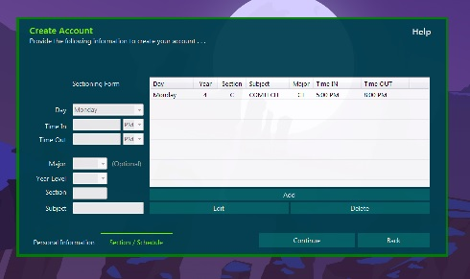

**XI. Registering Students as Instructor**

1. First, click “My Class”.
2. Then select “add” to create an account for a student
3. Fill up all the information needed to be filled.
4. Then click “Update”.

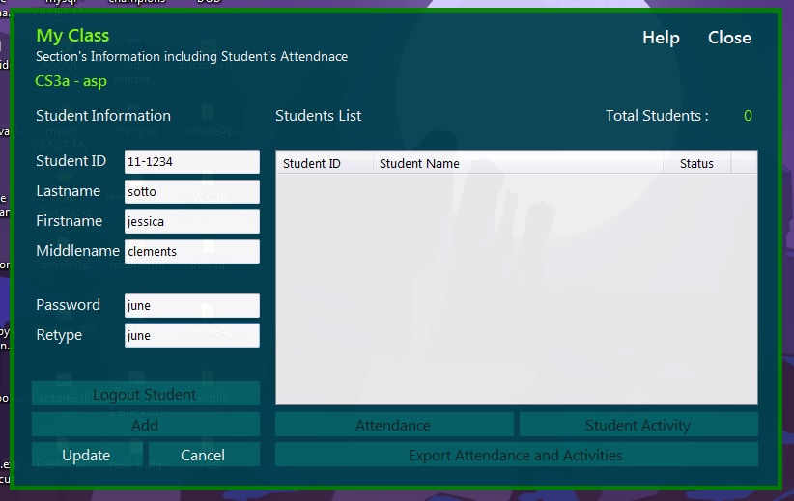

**XII. Registering Students as Client**

1. To create an account on the clients side. The default is **username: student** and **password: student**
2. To continue hit log in.
3. After logging in a form will show for the students’ information.
4. Fill up all the information needed.

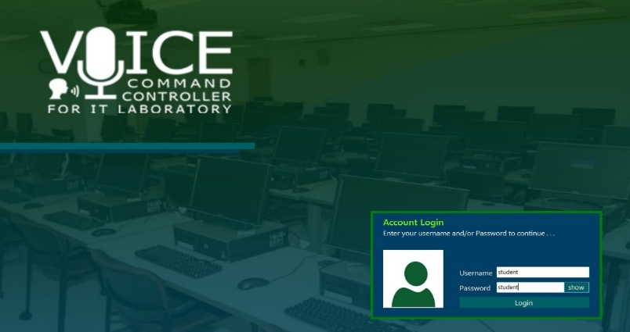

**XIII. Student Monitoring**

1. To see all of your clients current activity click on “Monitoring” on the menu dashboard.
2. To maximize the screen of the client “Double-click” the clients screen.
3. To control and set some exemptions on the clients terminal “right click” then choose a control.

**XIV. Screen Sharing**

1. Log in as a professor.
2. Click “start listening” or say “server start listening”
3. Say “start screen sharing”

**XV. Setting the Laboratory Timer**

1. To set the timer for the clients click on “client timer”
2. Set the desired amount of time for the clients.
3. To set the time hit “continue” or say “continue”.
4. To start the time say “start”.

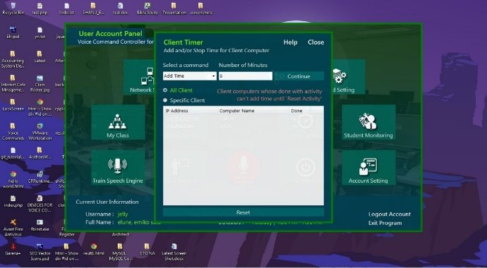

**XVI. Viewing and Exporting Attendance**

1. To export daily reports like attendance and activities click on “My Class” at the menu dashboard.
2. Inside the “My Class” hit on “Export Attendance and Activities”.

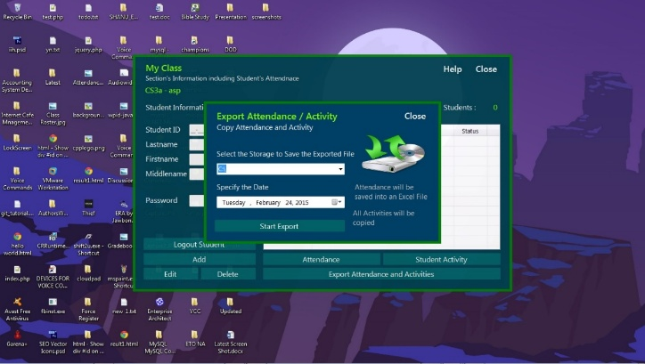

**XVII. Shared desktop Using voice command**

1. To start screen sharing the instructor just need to say “ start screen sharing “
2. To stop screen sharing the instructor just need to say “ stop screen sharing “
3. **Sending of files from the server to the clients**

In sending the file from server to clients the instructor has the ability to send files to all clients or specific clients.

1. To send files from server to all client just say “ <command for sending files> and to send files to specific pc just say <command>
2. **Alternative Voice Command**

This module is to control the system when the wireless device is not working well.

1. To open the module click  to the dashboard.

